CIS 207 Final Project
Group 8
Project Proposal and Project Design
Key:
Bold sections are section delimiters
Underline sections are requirements
Group Members:
Nicholas Roberts
Robert Heron
Michael Colbert
Joey Kingsbury
Website Description:
A small website dedicated to travel featuring Gatlinburg and Pigeon Forge locations, their attractions, restaurants, and lodgings.
The Purpose:
The purpose of our website is to inform tourists, vacationers, and even potentially locals about various attractions, lodging, and restaurants within the locations of Gatlinburg and Pigeon Forge Tennessee. It will offer a brief description of the various topics while also providing a link to external information hosted elsewhere should the viewer wish to look deeper at the attraction, lodging, or restaurant.
The Target Audience:
As previously mentioned the audience is intended to be tourists, vacationers, and even potential locals.

The Front Page:
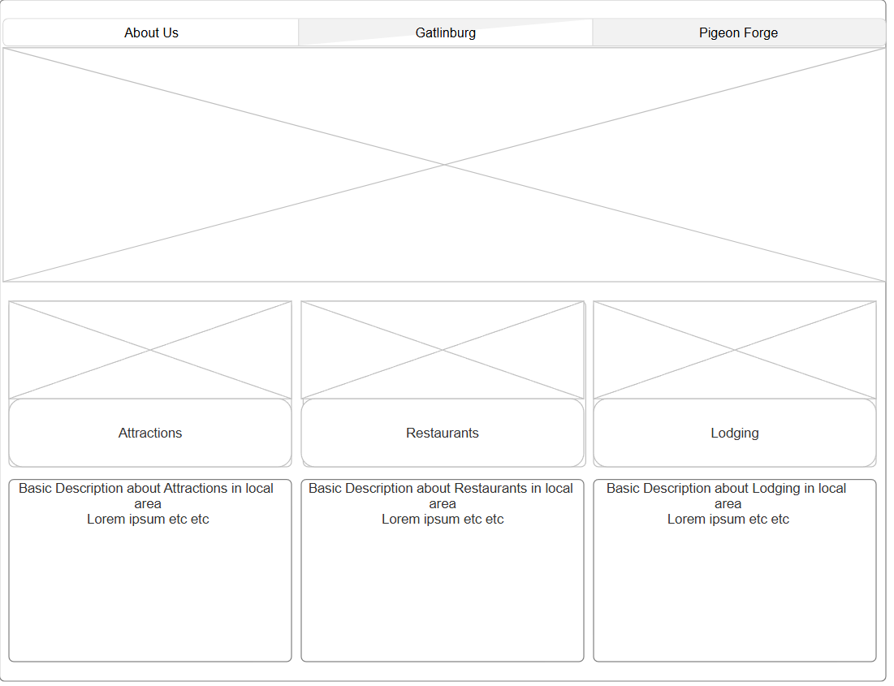
This page is formatted with three buttons across the top of the page. This will be a two-level navigation bar. The buttons take the user to a new webpage. About Us – About Us Page, Contact Us Page. Gatlinburg – Gatlinburg Page, Attractions, Restaurants, Lodging. Pigeon Forge – Pigeon Forge Page, Attractions, Restaurants, Lodging.
Below the buttons will be an area view image of the local area(s). The image will transition between Gatlinburg and Pigeon Forge with Image Rollover when hovered.
Below the local area image will be another trio of buttons, each with their own image related to the button. The buttons are links to Attractions, Restaurants, and Lodging which pages will have more information on each.
Underneath each of these button segments will be a very brief description of the common style of attraction, restaurant, or lodging available.

About Us:
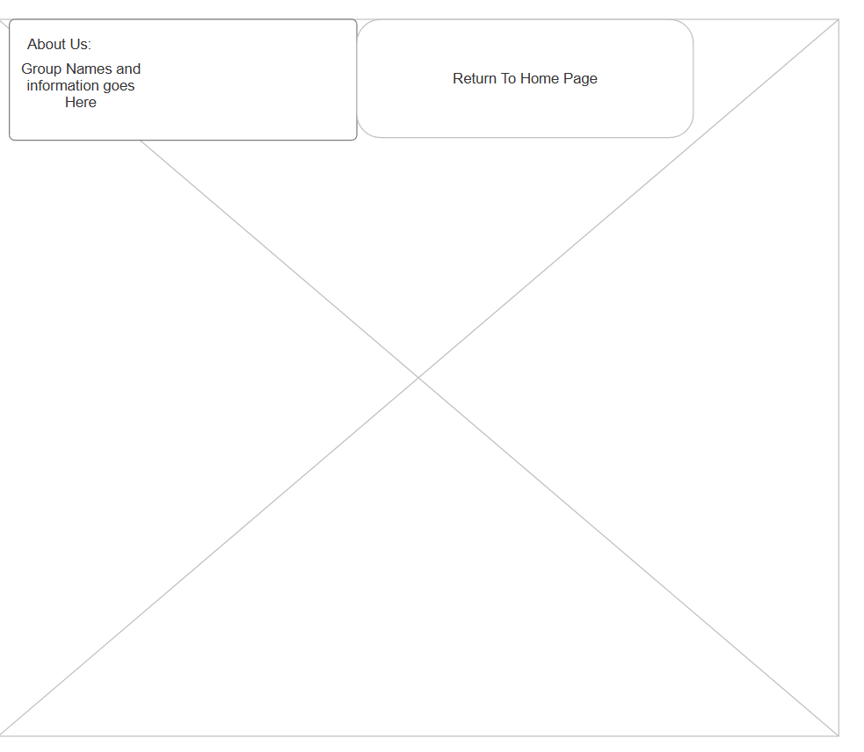
A basic image of some form of stylization as a background with group information and names in the top left. A single button to return to the home page exists here.

Gatlinburg:
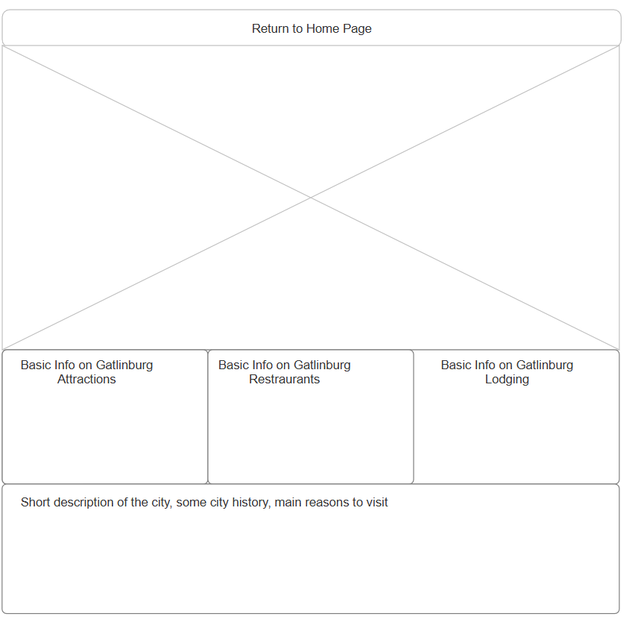
Top of page will be a return to home page button. There will be an aerial view image of Gatlinburg and its surrounding area below it. There will be three segments talking briefly about specific attractions, restaurants, and lodging in Gatlinburg. There will be a short description of the city’s culture, history, and surroundings. The Gatlinburg page will feature an image cycle coded in Javascript to cycle the main image through at least two options.

Pigeon Forge:
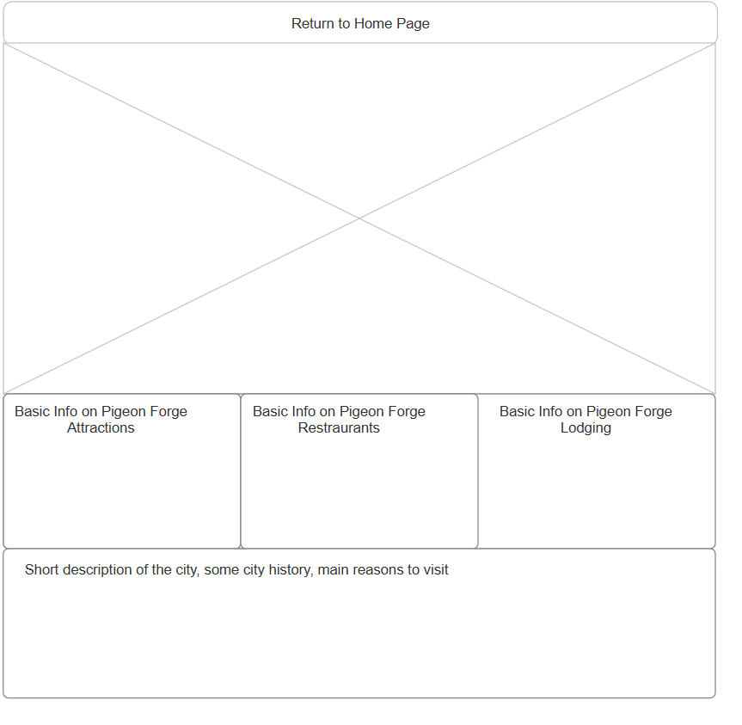
Akin to the Gatlinburg Page the formatting is the same with Pigeon Forge being the focus instead. Likewise the Pigeon Forge page will feature Pigeon Forge images with its javascript.

Attractions:
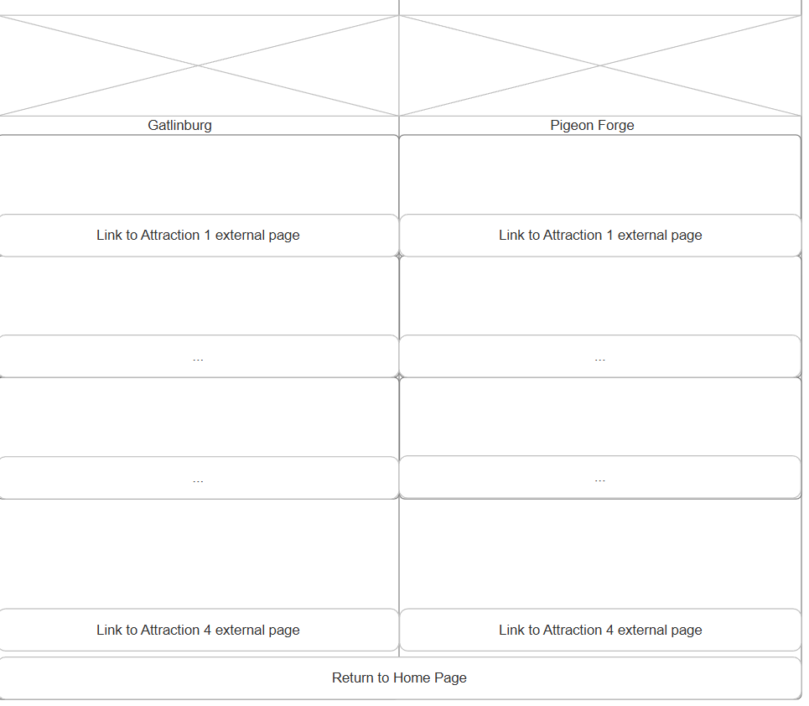
The Attractions page will have the two locations side by side. Images of an attraction in Gatlinburg and Pigeon Forge will top the page. Below will be a description of four different attractions within each city, each having their own external page link to the attraction [ie: to Wikipedia]. The return to home page will be at the bottom of the page.

Restaurants:
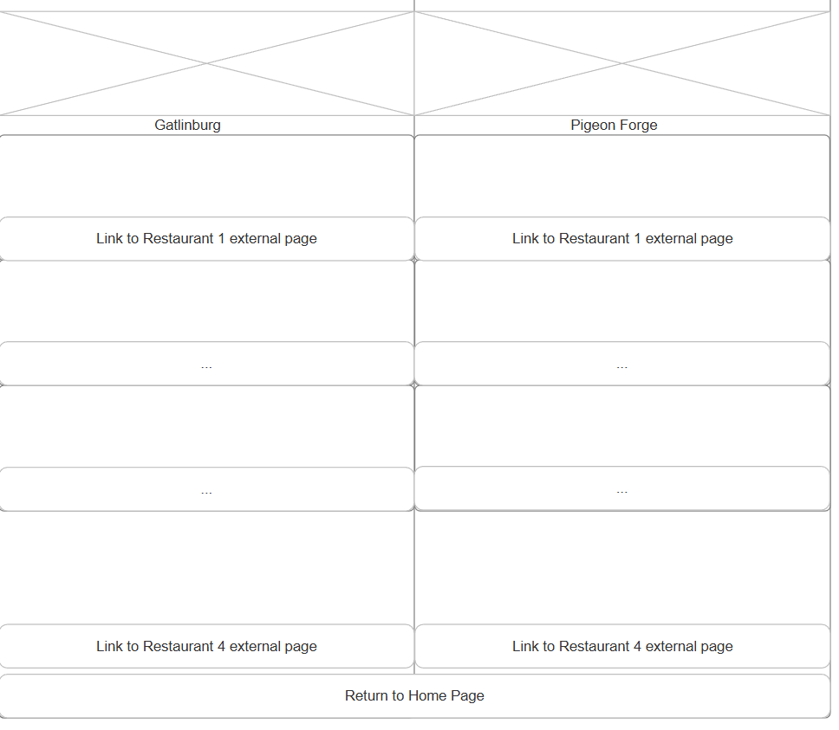
The Restaurants Page will be akin to the Attractions page in formatting but with restaurants instead of attractions.

Lodging:
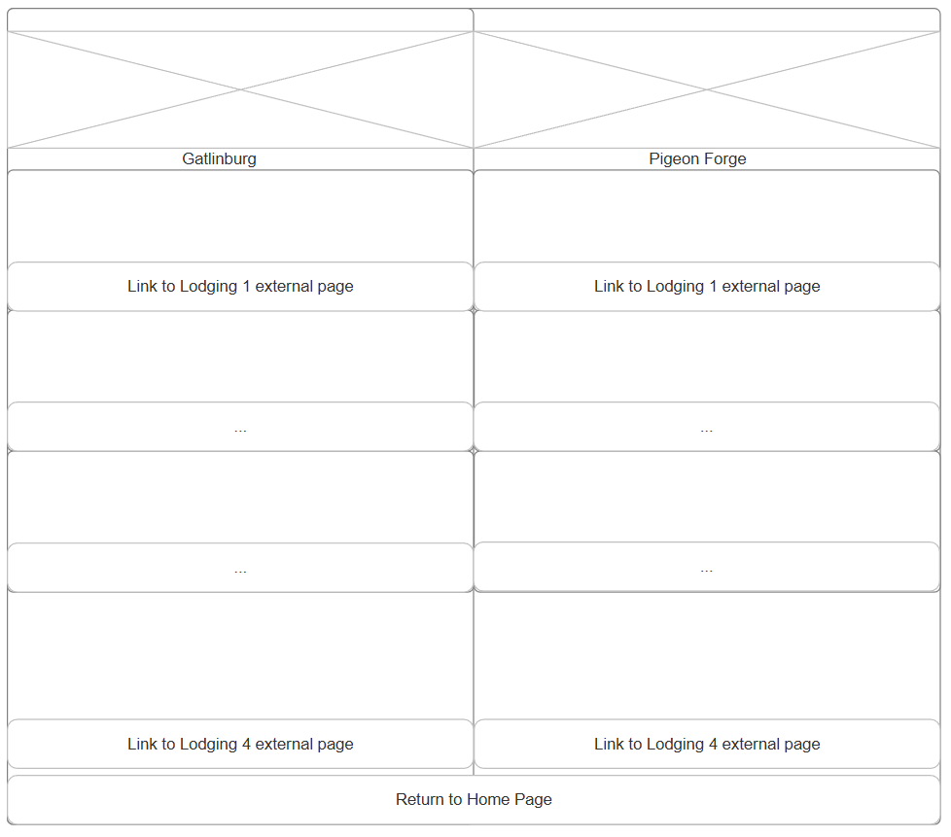
The Lodgings page is formatted the same as the attractions and restaurants pages. With of course the Lodgings being featured instead.

Contact Us:
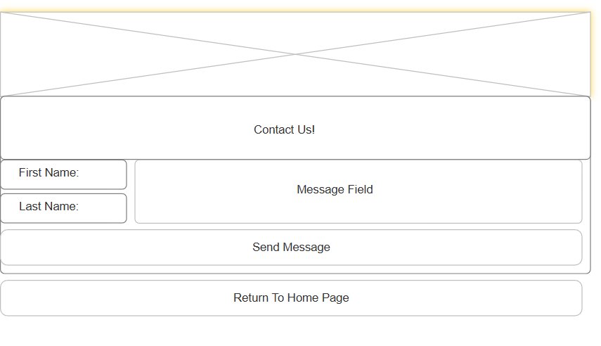
The Contact Us page will feature a generic image at the top for aesthetics along with large bold text informing the user to “Contact Us!” There will be web form user input boxes for a First Name, Last Name, and message Field. With a Send Message placebo button. The Send Message placebo button will change the text in the Message Field to ‘Message Sent!’ and clear the first and last name fields. The bottom of the page will feature a return to home page button.

